Milestone 4 mei

Day 1 March 11th, 2024

1. Install poetry add :
   * Flask ✅
   * SQLAlchemy ✅
   * Flask-SQLAlchemy ✅
   * python-dotenv ✅
   * flask-smorest ✅
   * Marshmallow ✅
   * mysql-connector-python ✅
2. create utils as connecting to database of SQLAlchemy
3. create __init__.py to ensure the route is accessed
4. Create connector so I can access database with my flask project
5. create database, tables and their columns (it’s a little bit challenging but I’m proud of myself)
6. create connector module
7. create models
8. create views so I can track documentation in swaggerUI and create blueprints in __init__.py

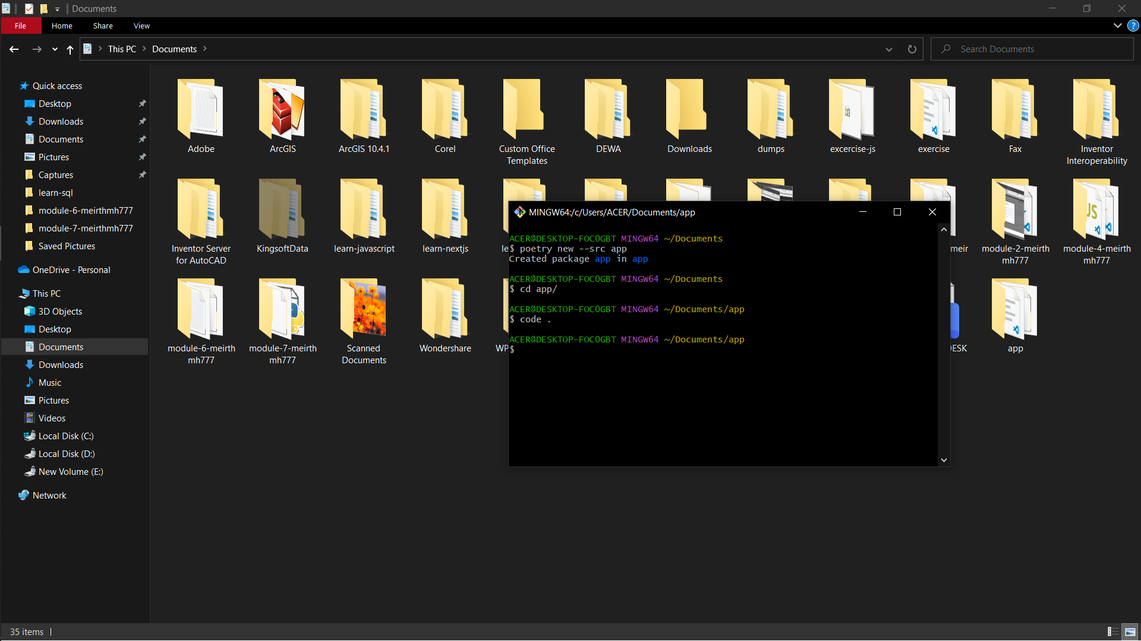

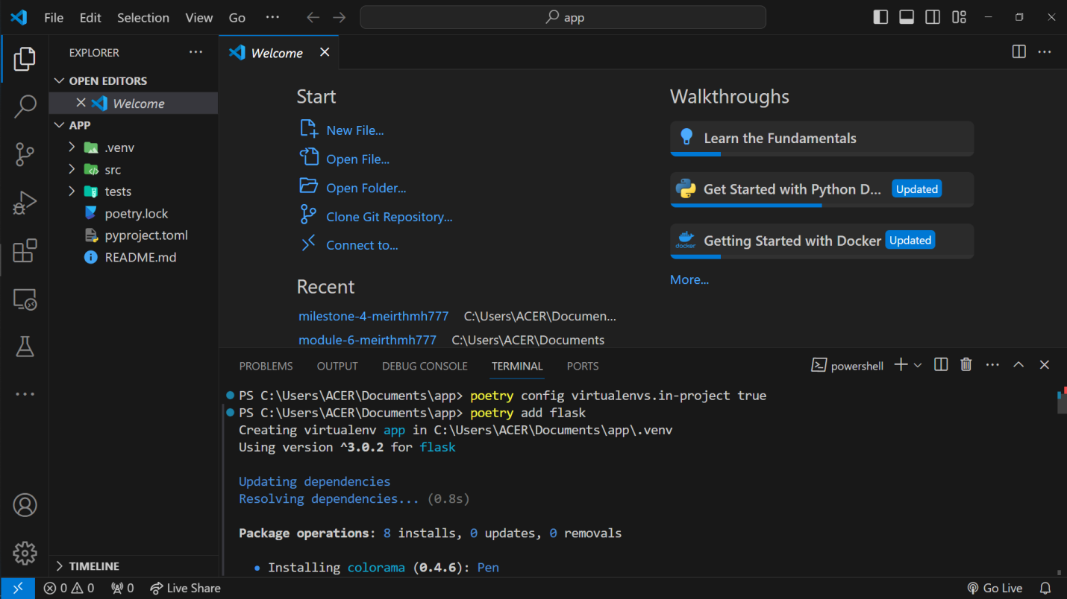

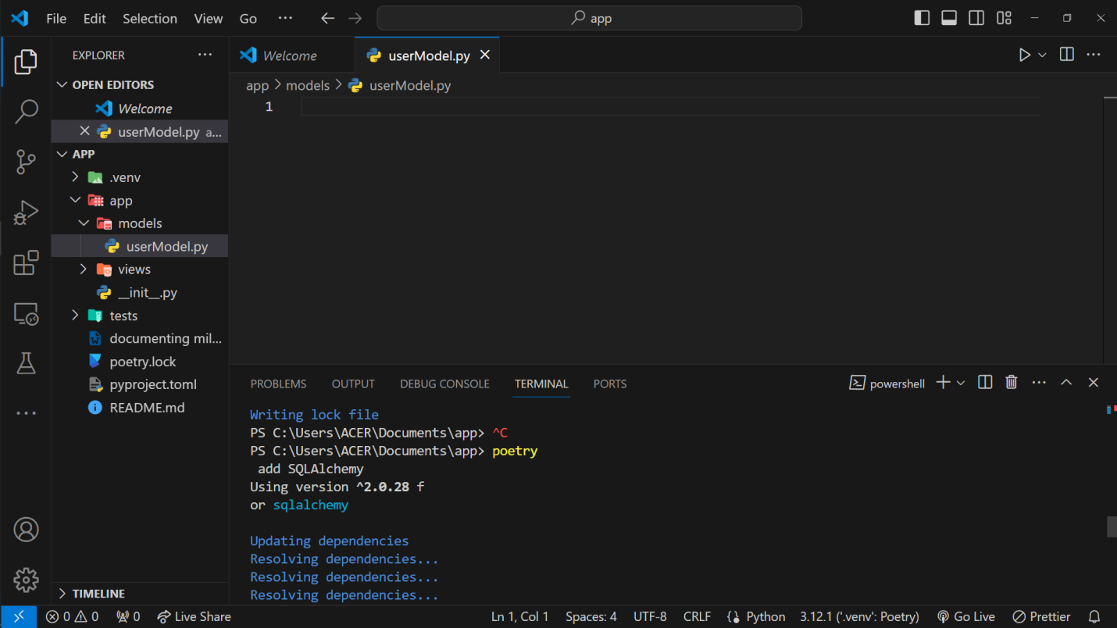

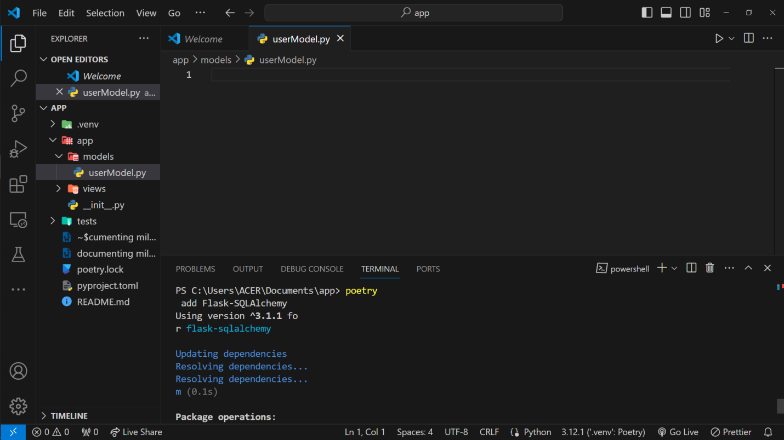

Day 2 March 12th, 2024

1. Install poetry add :
   * flask-login ✅
   * Bcrypt ✅
   * Flask-JWT-Extended ✅
2. Create controller for user register, login and logout
3. Because of my users cannot hit endpoint in thunder client so I do flask migrate
   * Flask-Migrate ✅
   * Then run this command in terminal
4. poetry run flask db init
5. poetry run flask db migrate -m "try migration"
6. poetry run flask db upgrade
7. Then rerun flask app: poetry run flask run

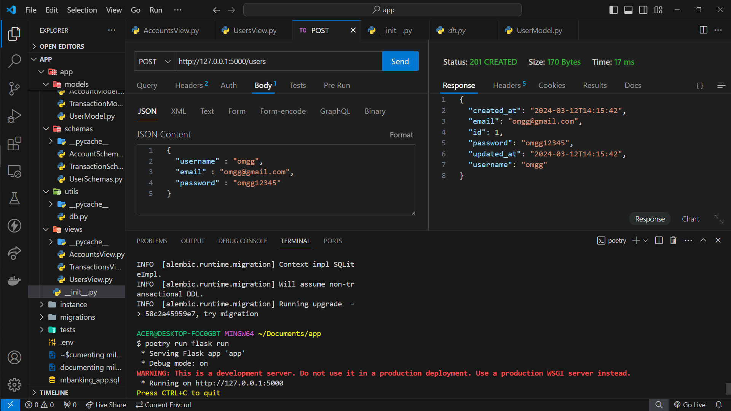

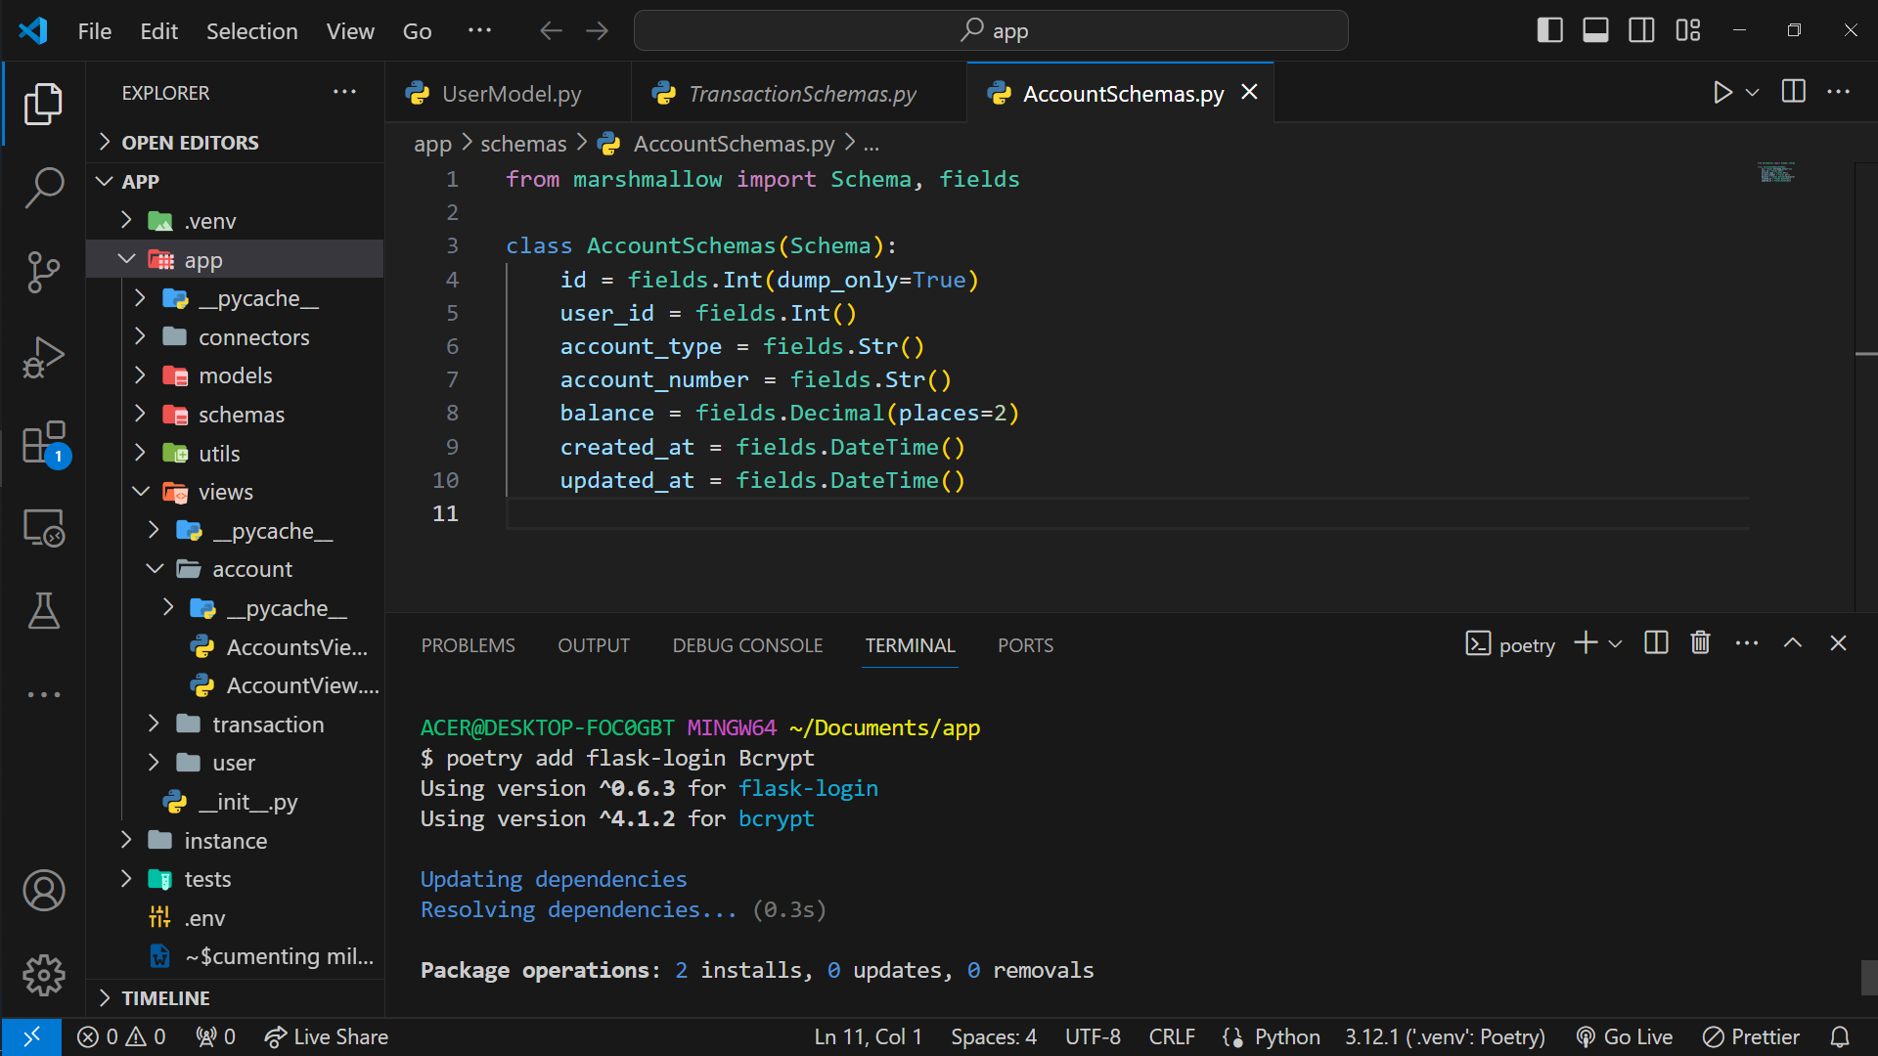

Day 3 March 13th, 2024

1. Check if I can hit endpoint in thunder client
   * I learn why swagger ui cannot render my post method. Turns out because it has @login_required decorator on top of @blp.route decorator.
   * Don’t forget to return item each method.
   * "user has no update attribute" this action makes me modified current code of post method

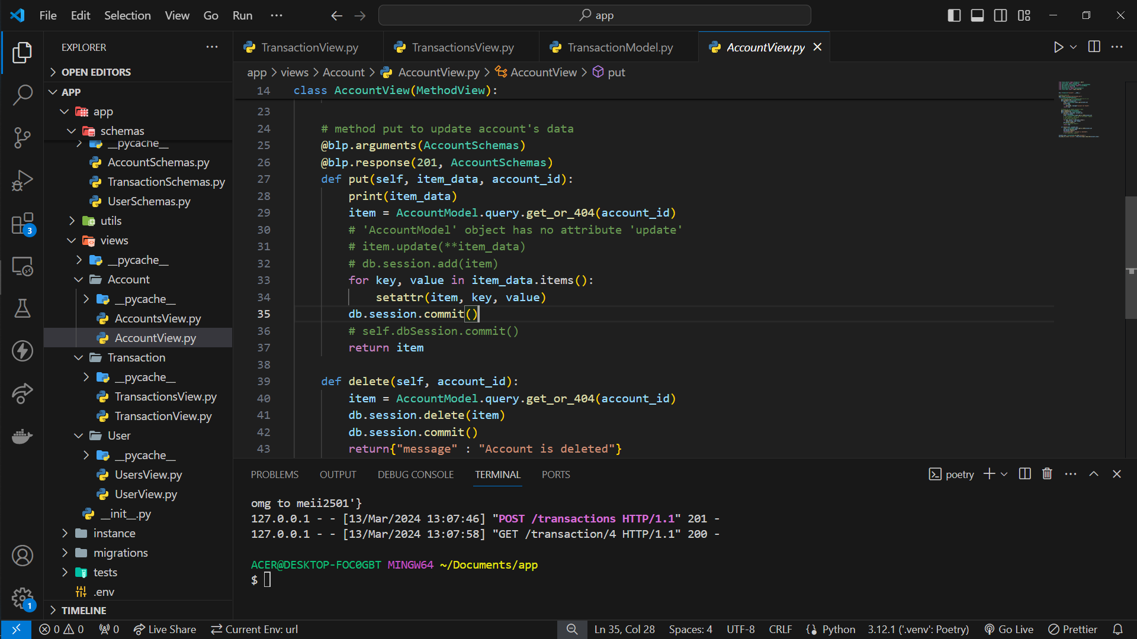

Day 3 March 13th, 2024

1. Okaayyyy I’m struggle in authentication dude. Still I have no Idea